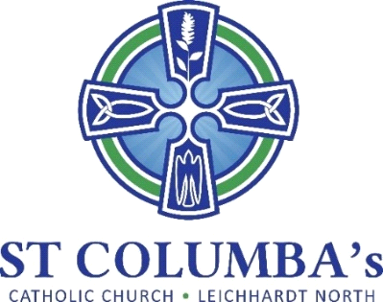

Parish Pastoral Council Meeting
MINUTES

Tuesday 12 September 2023, 7.30 pm
St Columba’s Parish Hall Meeting Room

ITEM | BY
1. Welcome, Opening prayer and reflection  Acknowledgement to Country | David Hair
2. Attendance /Apologies  Present: Fr. Peter, David Hair, Debra Galofaro, Jennifer Cheal, Ray Choi, Therese Pacey  Apologies: Amanda Gardiner, Mirele Farina (resignation from committee  tendered effective immediately) | David Hair
3. Minutes of the previous meeting  Approved | David Hair
4. Business arising from previous meeting  - Training on laptop is complete and the device is now in use in the church. To improve WiFi reliability and bandwidth it is recommended to introduce a WiFi extender.  - Payment of $1k was paid to the ACM. | Ray Choi  Amanda Gardiner
5. School report  - Report provided  - An information evening for parents will be held 11 October. Open to all parishioners. Flyer to be prepared. | Debra Galofaro  Amanda Gardiner
6. Sacramental Program  - Report provided | Amanda Gardiner
7. Sub-committee Reports  Spiritual Journey – no report  Social Justice / Outreach – report provided  - Kitchen Table Conversation has been advertised but needs to be further promoted. Suggest the event be further promoted during each Mass one weekend.  - The Care for Creation banner should be displayed for September (early Oct). Debra recommended it be put up on the school fence.  Engagement / Communications – report provided | Amanda Gardiner  David Hair  David Hair / Amanda Gardiner  Jennifer Cheal
9. New Items  - A cleaning bee for Church will be held on 4 November, 9am – 12 noon.  - A few items of maintenance will be addressed including:  - Reviewing the lifting paneling in the Church and determining remedial action  - Lighting in the Church  - Painting the outside of the Church and the Sanctuary inside.  - To progress refreshing the garden it was suggested a landscape gardener be engaged. The Aboriginal Land Council could be approached for ideas.  - The need for new committee members is being advertised but no response to date. This will be held over and discussed in February 2024.  - The Pets Mass will be held in the School grounds on 22 October at 9am (combining 8 and 10am masses). Request people bring a plate to share for morning tea. Tea and coffee will be provided. | Therese Pacey  Fr. Smith  Fr. Smith  Jennifer Cheal  Amanda Gardiner

