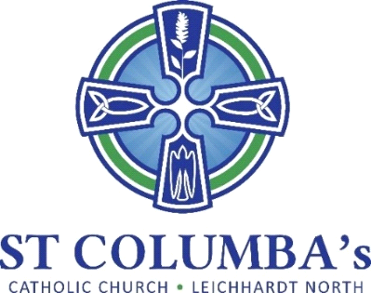

Parish Pastoral Council Meeting
MINUTES

Tuesday 20 June 2023, 7.30 pm
St Columba’s Parish Hall Meeting Room

ITEM | BY
1. Welcome, Opening prayer and reflection  Acknowledgement to Country | Fr. Peter  David Hair
2. Attendance /Apologies  Present: Fr. Peter, David Hair, Jennifer Cheal, Amanda Gardiner, Therese Pacey,  Apologies: Debra Galofaro, Mirele Farina, Ray Choi | David Hair
3. Minutes of the previous meeting  Approved | David Hair
4. Business arising from previous meeting  - Specifications for new laptop agreed. Purchase to follow.  - Parish ‘cuppa’ promoted in bulletin and on Facebook.  - Dates for PPC meetings and other events added to calendar. | Ray Choi  Jen Cheal
5. School report  - Report provided | Debra Galofaro
6. Sacramental Program  - Report provided  - Archdiocese is introducing a new sacramental program. AG will attend info/training sessions. | Amanda Gardiner
7. 90th Anniversary Celebrations  - Report provided  - Pictures of the event will be printed and displayed in the church. | Therese Pacey  Amanda Gardiner
8. Sub-committee Reports  Spiritual Journey – no report  Social Justice / Outreach – report provided  - Feedback from the Aboriginal Mass ‘Walking Together in Faith’ was very positive. There was a real sense of reconciliation.  - It was agreed to make a cash donation of $1,000 to the Aboriginal Catholic Ministry. AG will arrange with Vanessa.  - Proposal to procure a ‘Yes 23’ banner to show support for the ‘Voice’ referendum. DH will investigate. Need to be careful of messaging.  - We could hold a public forum closer to the referendum date providing information and hospitality (pizza & wine).  - Fr Peter suggested, and it was agreed, the garden be refreshed with new plants and include totems.  Engagement / Communications – report provided  - Need to put a shout out for new committee members. | Amanda Gardiner  David Hair  Amanda Gardiner  David Hair  Jennifer Cheal
9. New Items  - Items raised in the recent survey:  - Put holy water in fonts (already done)  - Add the Confiteor, Gloria and Creed (included as necessary)  - Use more inclusive language (the readings cannot be changed but where possible ie. Prayers of Intercession inclusive language is used) | David Hair

