Parish Council 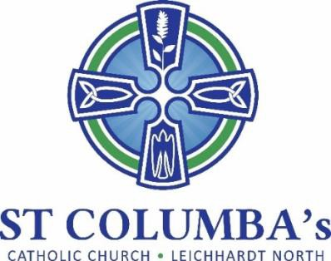MEETING MINUTES

Tuesday 23 November 2021 7.30 pm

ITEM | ACTION
1. Welcome, opening prayer and reflection:
Opening prayer by Fr. Peter | No action required
2. Attendance / Apologies:
Present: Renata Popovic-Tomac, David Hair, Debra Galofaro, Fr. Peter, Jennifer Cheal, Therese Pacey, Nicola Connors, Anne Coffey, Ray Choi  Apologies: Tino Mian | No action required
3. Minutes of the previous meeting to be moved:
Accepted | No action required
- Business arising from previous meeting:

Nil
6. School report
Delivered by Debra Galafaro:  - Appointments/Recruitment:  - Megan Owens, Assistant Principal  - Angela Tierney, REC (was acting AP)  - Nicola Connors is taking 12 months leave so we will recruit a temp replacement.  Thanks to Fr Peter for his support with these activities.  - Return of Face to Face teaching – very proud of students, parents & teachers. Everyone working together and it is lovely to be back.  - School continues to be guided by Covid rules & is closely following restrictions.  - Graduation Mass for Year 6. Vaccinated parents can attend but others can participate via zoom.  - Playground equipment will be installed during Christmas holidays. The equipment refresh will cater to all ages. | No action required
7. Sacramental Program
Delivered by Nicola Connors:  - First Holy Communion Program has commenced and run over 5 weeks.  - Celebrations will be part of the normal as happened last year. | No action required
8. Christmas Masses
- Christmas celebrations will be the same as last year with 2 masses outside –vigil at 6pm and morning at 9am.  - It would be good to have a Marquee in case of rain.  - Will need a lot of volunteers for check-ins (wait to see covid requirements)  - Ask Gus to run the PA for both masses.  - Ask John Jacobs if he can play at 9am mass. | Fr Peter  Nicola  Nicola
9. Parish sub-committee updates
Social Committee  - Advice from the Archdiocese is no social events at this stage.  Social Justice  - Last meeting of year is 1 December.  - JRS contributions will be starting up again with a focus on different item/s per month.  - Delivery of goods occur on Tuesday and Thursday & could use assistance. Ray has offered support.  - Debra indicated the school would like to support. Could ask parents for assistance.  - St Vinnies Christmas appeal for voucher/hampers will happen on 4/5 December.  Liturgy – Nil  Communications – Nil  Social Media  - Jennifer has contacted the websites hosts and is awaiting their advice. | David  Jennifer
8. New Items
- Marcia has resigned. She has taken up a full-time role.  - We have engaged a temp, Bernard, filling in while recruitment is finalised.  - An agency has screened candidates and Fr Peter and Debra have interviewed and will make a decision. Fr Peter will talk to the agency for next step.  - The selected candidate will start in the new year.  - Marcia prepared a handover documentation.  - The use of QR codes at masses seems to be working well.  - We need to get more volunteers to assist.  - Diocese have found that a lot of people have not come back to masses for several reasons:  - Confusion  - Different online options  - Many anxious.  - Covid safe nativity for children is planned for Christmas.  - For Christmas masses we will use the school sound system as the parish system is dodgy.  - When investigated previously a replacement was too expensive but we should re-investigate. The school could use it as well. Nicola has a friend who may be able to assist or check with James (the IT guy).  - Welcome to Ray Choi to has joined the Parrish Council.  - Next meeting in Early Feb – spill roles and refill | Fr Peter / Debra  Nicola  Nicola / Fr Peter

Next meeting: TBA – early 2022

