Parish Council 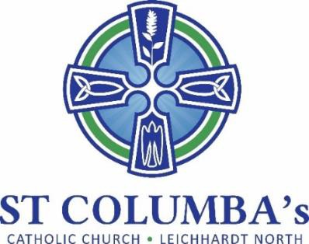MEETING MINUTES

Tuesday 8 June 2021 7.30 pm
Meeting at St Columba’s Parish Hall.

ITEM | ACTION
1. Welcome, opening prayer and reflection:
Opening prayer by Fr. Peter | No action required
2. Attendance / Apologies:
Present: Renata Popovic-Tomac, David Hair, Bernard Ryan, Fr. Peter, Ann Coffey, Adrian Overs, Jennifer Cheal, Therese Pacey  Apologies: Nicola Connors, Tino Mian | No action required.
3. Minutes of the previous meeting to be moved:
Moved by: Adrian Overs  Seconded by: Renata Popic-Tomac | No action required.
- Business arising from previous meeting:
  - Social Media
- Met with Felicity – In relation to Social Media we need to make decisions to determine direction  - Felicity provided a list of questions to assist us to set a strategy – we need to decide:  1. Who we are as a parish;  2. What we need to be known for / what is important to us;  3. What stories do we tell.  - Answers to these questions have an impact in how we deliver information and design an effective website.  - Further considerations:  - Design, colours, fonts etc to create templates  - Number of tabs for specific content (ie. Information, Social Justice etc)  - Demographics unknown as we have not had a census in some time  - Use of Instagram more appropriate for youth of the parish.  - Felicity has arranged for some analytics on our website. Data could determine how we can make it more user friendly  - Recommend the Parish Council members meet to discuss suggestions and determine forward direction.  - Meeting date – Saturday, 17 July – 9am to 11 am in the Hall.  - Invite some parish youth and ask them what they want | Jennifer
- St Columba’s feast day
- Was a great success with a good rollup.  - Thanks to all involved. | No action required
6. School report
Delivered by Bernard Ryan.  - Interviews for 2022 Enrolment in Kindergarten are completed. Currently offering places to those successful.  - The School Captains and Vice Captains attended Mass at St. Mary’s Cathedral on 24 May to mark the Feast Day of Our Lady Help of Christians. It was also the national mass to celebrate 200 years of Catholic Education in Australia.  - School Athletics Carnival was held on 20 May at King George Park Rozelle.  - The Sacrament of Confirmation is compete. Thanks to Fr Peter and Nicola for leading our students  - Today a celebration for the Feast Day of St. Columba’s was held which included a Mass and brunch with students, families and teachers. The school shared spaces were given formal names associated with school history and culture.  - The P&F are holding a trivia night on Friday 18 June. | No action required
7. Parish sub-committee updates
- Social Committee  Need to start thinking about a Christmas event  - Social Justice  - Support for JRS continues.  - Thanks to all who helped with cuppas and sausage sizzle. Money collected on the weekend will go to Timor.  - Consul General of Timor Leste would like to attend Mass at St Columba’s to offer his thanks.  - NATSIC – 4 July  - Liturgy – Nil  - Communications.  - Over 1,000 downloads (43 episodes) of Fr Peter’s podcast  - 20 downloads of Fay Hair’s podcast.  - Bulletin continues to go out.  - Social Media – Nothing further to add from above | Tino  David  Therese  Jennifer

8. New Items
- Finance Committee meeting reported Parish account is strong.  - Collections at Masses are relatively poor.  - Child Care Centres are difficult to run. A company has been engaged to send out invoices, collect and hand over money. We will continue to maintain centres / insurance.  - Finance Committee is considering making changes to automatic deductions. Looking to put out a form were auto deductions can be nominated including options for:  - 1. Pastoral revenue  - 2. Second collection – salaries & cost of running parish  - 3. Nominated Charity – donate for the next 12 months (cana, aboriginal literacy, backtrack aboriginal support) | Fr. Peter
,
Next meeting: 7:30pm, Thursday 20 July 2021

