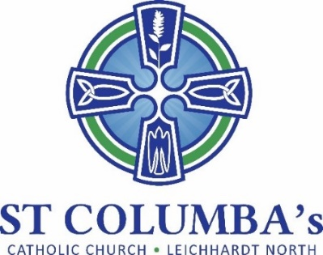

Parish Pastoral Council Meeting
MINUTES

Tuesday 7 June 2022, 7.30 pm
St Columba’s Parish Hall Meeting Room

ITEM | BY
1. Welcome, Opening prayer and reflection | Fr. Peter
2. Attendance /Apologies  Present: Debra Galofaro, Fr. Peter, Therese Pacey, Ray Choi, Barbara Howard, Mirele Farina  Apologies: David Hair, Amanda Gardiner, Jennifer Cheal | Therese Pacey
3. Minutes of the previous meeting  Approved | Therese Pacey
4. Business arising from previous meeting  Strategic Planning Day - Report from discussion held over to next meeting as Jennifer an apology for this meeting.  Debra spoke to the head IT who suggested Clare Communications be contacted regarding purchase of a new sound system. A visit has been organised. Suggest 2 quotes on the sound system and the stand alone system  Planning for 90th anniversary celebration of the Parish. Mirele and Therese will consider options and put to council for discussion.  Barbara will sort through a box of material for a photographic display. | Jennifer Cheal  Debra Galofaro  Mirele/Therese  Barbara Howard
5. School report  - School reports are currently being completed  - Enrollment offers to Kinder have gone out  - Pope Francis award for year 6 students – volunteer time to healp the community.  - Mini Vinnies program has restarted – Winter sleepout, students created a video to parents re refugee dinner.  - Stop, Pray and Reflect (SPR) have recommenced (AG). Reflection and craft. Good rapport with parents & students love her. Reconnecting with the community.  - Police Cyber Safety returning to run a follow-up session | Debra Galofaro
6. Sub-committee Reports  Social  Weekend cuppa after Masses end May  Social Justice  - Monthly meetings going well with an average 8 attending. Last meeting 4 June.  - Focus for June - Refugees (in collaboration with School)  - Speakers to attend Masses on 25/26 June.  - Parish Dinner on 25 June  - To be catered for by social enterprise arm of House of Welcome (HOW)  - Parish will cover costs of food and drinks with parishioners asked for donation to HOW  - School volunteers will setup the hall on Sat afternoon 3pm  - Request volunteers from the PPC to serve drinks  - Serve tea/coffee – SJG  - Cakes – School is asking for volunteers  - Focus for July - First Nations  - Robbie Lloyd from Justice and Peace Office is coming to our next meeting to guide us on how to do this.  - Inviting Aboriginal Catholic Ministry to speak at masses on a day to coincide with parish cuppa.  - Focus for September- Environment  - Parish purchased a banner promoting climate change action by 2030. It will be put back up in September for “Care for Creation Month”.  Liturgy  A meeting should be setup to discus returning to pre-covid practices such as:  - offertory procession  - welcome to mass  - consider the collection  Communications – No report | David Hair  David Hair
7. New Items  Sacramental Progam  - In the middle of Confirmation Program  - Celebration on 17 June with Bishop Terry  - Celebration on 1 July Bishop Danny  - 26 Children participating (all but 4 from St Columba's)  - Notices to go out for First communion after school holidays in 3 term  St Vinnies Winter Appeal to be held 23/24 July. Students & families to attend Masses is yet to be decided | Barbara Howard

Next meeting: 19 July 2022
Remaining Meetings Dates for 2022:
- 19 July
- 30 August
- 11 October
- 22 November

