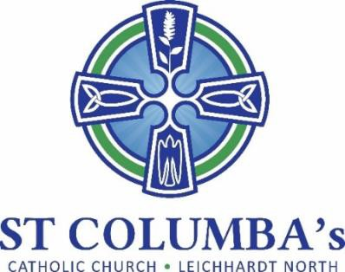

Parish Council MEETING MINUTES

Tuesday 16 March 2021 7.30 pm
Meeting at St Columba’s Parish Hall.

ITEM | ACTION
1. Welcome, opening prayer and reflection:
Opening prayer by Fr. Peter | No action required
2. Attendance / Apologies:
Present: Renata Popovic-Tomac, Therese Pacey, David Hair, Bernard Ryan, Fr. Peter, Jennifer Cheal  Apologies: Tiano Mian, Nicola Connors & Adrian Overs | No action required.
3. Minutes of the previous meeting to be moved:
Moved by: David Hair  Seconded by: Renata Popovic-Tomac | No action required.
- Business arising from previous meeting:
  - Social Media
Presentation from Felicity has been viewed and found useful. Initial discussion has taken place but Jen proposes a meeting with Felicity and Tino to plan how best to utilize social media to suit St Columba’s needs.  Draft update of text on Homepage of website has been sent for review. Need to check if there is a particular format we should use. Agree the Homepage should remain static with separate links updated (ie. Bulletin, Podcast, Sacraments, Covid).  Propose recent photos are sourced as part of update. Check with Marcia / Nicola | Jennifer  Jennifer
4. Business arising from previous meeting:
  - Diocese pastoral planning
No update. Whole day clergy conference scheduled for next Tuesday | Fr. Peter
5. Easter Program
Covid Precautions are still applicable. No specific directives so presume we’ll operate as current.  Attendance on Holy Thursday is normally light and can remain in the Church. Good Friday, Saturday Vigil and Easter Sunday are well attended, and numbers will need to be limited. Christmas Masses worked well being held in the school grounds so propose holding Masses there again. As weather can be temperamental suggest hiring a marquee. Some chairs can be made available.  Will need volunteers to be rostered for all Masses.  Will require a PA for outdoor services. Fr. Peter to talk to Nicola. Do we have a hand-held option?  Palm Sunday – No palms to be handed out. People to bring their own.  Holy Thursday – no washing of feet.  Good Friday – No veneration of the Cross.  Easter Vigil – No candles.  All Masses – Singing still restricted. | Fr. Peter
6. School report
Delivered by Mr. Bernard Ryan.  - Four new teachers have commenced.  - Term 1 has commenced and students have settled in well.  - There has been a relaxing of Covid rules in the school allowing parents in the playground in the afternoons, parents to attend school representative sports, canteen and singing.  - School Open Day is being held next week. Parents will attend in groups and will commence their tour with a video prepared by students.  - 200 years of Catholic Education in Australia this year. The School celebrated the launch this week to align with the feasts of St. Patrick and St. Joseph.  - Sacramental program is underway with Reconciliation meeting being held via Zoom. Confirmation preparation will commence in Term 2. | No action required
7. Parish sub-committee updates
- Social Committee – Nil  - Social Justice  - Looking to promote the ‘Uluru Statement from the Heart’.  - The committee is making a submission of behalf of the parish to have enshrined in the Constitution. This would provide a voice to parliament for our First Nations people.  - To be mentioned in an upcoming newsletter.  - Request a copy of the letter to be sent to Parish Council members.  - Committee would like to focus on helping Timor Leste during Covid. It is thought we could make masks or buy materials and send them for locals to make. Would require fundraising of some sort.  - Liturgy - Nil  - Communications – We have commenced paying the monthly podcast fee. There is quite a good following of downloads as well as listeners.  - Social Media – Nothing further to add from above | David Hair  Jennifer Cheal
8. New Items
- Vassile Tiano resigned from the role of Secretary prior to this meeting. The committee would like to thank Vassile for his valuable contribution to the St. Columba’s Parish Council. We wish him well.  - After Easter a campaign to invite new members to join the Parish Council should take place. Perhaps someone could speak at Mass.  - Fr. Peter is going on two weeks leave after Easter services. | Fr. Peter

Next meeting: 27 April 2021

