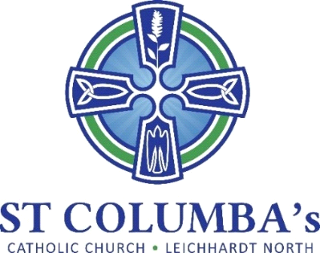

Parish Pastoral Council Meeting
MINUTES

Tuesday 10 October 2022, 7.30 pm
St Columba’s Parish Hall Meeting Room

ITEM | BY
1. Welcome, Opening prayer and reflection  Acknowledgement to Country | Fr. Peter  David Hair
2. Attendance /Apologies  Present: Fr. Peter, Barbara Howard, David Hair, Therese Pacey, Ray Choi, Debra Galofaro, Amanda Gardiner,  Apologies: Jennifer Cheal, Mirele Farina | David Hair
3. Minutes of the previous meeting  Approved with amendment to reintroduction date of activities at Mass to Beginning of Advent. | David Hair
4. Business arising from previous meeting  - Descriptions of proposed sub-committees was shared. While the content is fine it would be good to have the descriptions consistent. It was suggested the descriptions be rewritten to include Purpose, Aim and How these would be achieved. Review next meeting.  - A representative from the Pastoral Council should lead each sub-committee.  - Maintenance review of the grounds and structures performed and report sent to Fr Peter.  - 90th Anniversary celebrations.  - The Timeline on the website has been updated with details of serving Priests  - First Communion photos will be retrieved. | DH, JC, TP  DH, TP  Barbara  Amanda
5. School report  - The school received excellent results from the review if the Newman Program for gifted students. Accreditation was granted for 5 years.  - Awaiting approval for new playground equipment.  - There was some flooding in areas of the school. Carpets to be replaced in hall and store.  - Sydney Catholic Schools are funding refurbishment of demountables to accommodate more students in the NSW govt Aspect Program. This program supports high need students. The school currently accommodates 11 students but the positions are highly sought.  - Upcoming major fundraisers include the Christmas appeal and Catholic Education Foundation.  - Activities for term 4 include swimming, Graduation and Orientation for 2023 Kindergarten. | Debra Galofaro
6. Sacramental Program  Completed for this year. | Barbara Howard
7. Sub-committee Reports  Social  - Resulting from a discussion on what we could do as a Parish to celebrate Christmas is was decided that the School’s Carols/Christmas concert could be opened to Parishioners.  - This function is run by the school and includes presentation of end of year student awards.  - Scheduled for Tuesday 13 December.  - Commences at 5pm and doesn’t run too long.  - Parishioner could bring picnic rugs.  - Debra to arrange with Vanessa to add an invite in the Bulletin.  - Ask John Jacobs if he is available to perform.  Social Justice (SJ)  - Dr Robbie Lloyd attended the SJ meeting and provided information on forming relationships with Aboriginal groups. It was very informative and provided some good ideas such as forming connections locally.  - SJ will arrange for someone from the Burmali Arts Centre to talk to the Parish next year.  - Looking to organise a Sydney Cultural Harbour cruise managed by Tribal Warrior (Aboriginal group). The cultural cruise would take place around February next year. We would need a min of 30 people. The Parish could look to subsidise the event.  - SJ is working with the Parish Craft group to make beanies and blankets for Aboriginals in palliative care.  - Representatives from SJ plan to attend the Aboriginal Catholic Ministry Mass next month.  Liturgy  - Pets Mass will be held on 23rd October at 9am in the School grounds (under cover if raining).  - Students from the school will read. Amanda will help them prepare.  - Photos of students with their pets will be part of the Offertory Procession.  - Ask for attendees to bring a plate for tea/coffee after Mass.  - John Jacobs is very loud. Could we ask him to tone down.  Communications  - Barbara has updated some items on the website but still having difficulties.  - Ray will investigate further. | DG, AG, BH  David Hair  DG, AG, BH  Ray Choi
7. New Items  - Parish cleanup set for Saturday 12 November, 9am to 12 midday. Clean inside church and surrounding gardens. Barbara to arrange item in Bulletin.  - St Vinnies Christmas Appeal is scheduled for first weekend in December. | Fr Peter

Next meeting: 22 November 2022

