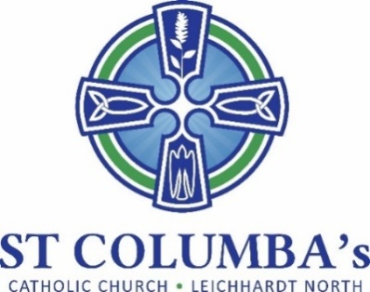

Parish Pastoral Council Meeting
AGENDA

Tuesday 14 February 2023, 7.30 pm
St Columba’s Parish Hall Meeting Room

 | ITEM | BY
 | Acknowledgement to Country, Welcome  Opening prayer and reflection | David Hair  Fr. Peter
 | Attendance /Apologies | David Hair
 | Parish Council positions to be formally released | David Hair
 | Elect Parish Council positions:  - Chairperson  - Secretary | David Hair
 | Minutes of the previous meeting | Chairperson
 | Business arising from previous meeting | All
 | School report | Debra Galofaro
 | New Committees  Feedback to Committee Purpose document | Chairperson
 | Sub-committee Reports | Various
 | New Items  - Rosters  - Weekend Masses | David Hair  David Hair

Next Meeting: 28 March 2023

